VENANGO TECHNOLOGY CENTER
JOINT COMMITTEE
1 Vo-Tech Drive
Oil City, Pennsylvania 16301

MINUTES

January 6, 2020

The regular meeting of the Venango Technology Center Joint Committee was held this evening in the Conference Room of the Venango Technology Center, 1 Vo-Tech Drive, Oil City, PA 16301. Mrs. Neely called the meeting to order at seven o’clock (7:00) p.m.

Mrs. Neely asked the members to pause for a moment of silence.

Mrs. Neely asked the members to stand for the pledge of allegiance.

Roll Call: Present: Troy Johnston, Todd Carson, Robert Blauser, Mark Marterella, James Disque,
Jeff Thomas, Shari Neely

Absent: James Come, Misty Nalepa, Don Judy

Also Present: Mr. Mario Fontanazza

Mrs. Neely stated the Joint Committee members had received copies of the Minutes of the December 5, 2019 meeting in the mail. She asked if there were any additions, corrections or deletions.

Mr. Carson, seconded by Mr. Marterella, moved to approve the Minutes of the December 5, 2019 meeting as submitted.

Roll Call: Ayes: Troy Johnston, Todd Carson, Robert Blauser, Mark Marterella, James Disque,
Jeff Thomas, Shari Neely

Nayes: None, motion carried.

The Treasurer and Secretary’s Report as of 1/6/2020 Special Account report for 1/6/2020 were submitted for information.

Mr. Marterella, seconded by Mr. Carson, moved to accept the Treasurer and Secretary’s Report and the Special Account report as of 1/6/2020 as submitted.

The motion was unanimously approved.

A list of bills from 12/6/2019 – 1/6/2020 in the amount of $713,197.90 was presented for approval.

Mr. Carson, seconded by, Mr. Blauser, moved to approve the list of bills as presented.

Roll Call: Ayes: Troy Johnston, Todd Carson, Robert Blauser, Mark Marterella, James Disque,
Jeff Thomas, Shari Neely

Nayes: None, motion carried.

Under Communications, Mr. Fontanazza discussed the Professional Advisory Committee minutes. He also discussed the Calendar of Events for the month of September and the Monthly Enrollment Report as of 1/6/2020 were submitted.

Mrs. Neely requested approval of the action items as presented. Item 8. a) i. –v. in one motion.

Mr. Carson, seconded by Mr. Marterella, moved to approve action items 8. a) i. –v. as follows:

- Approve additions to Occupational Advisory Committees.
- Approve Adult Evening School Schedule for Spring 2020.
- Approve list of equipment for disposal.
- Approve 2020-2021 Budget.
- Approve Travis Crate to attend the Torchmate training in Cleveland, OH on April 21-23, 2020 at a cost not to exceed $1,500.00. Funding - Local

Roll Call: Ayes: Troy Johnston, Todd Carson, Robert Blauser, Mark Marterella, James Disque,
Jeff Thomas, Shari Neely

Nayes: None, motion carried.

Mr. Fontanazza reviewed his Issues/Activities for December 2019.

Mrs. Neely asked if there was any old business.

None was noted.

Mrs. Neely asked if there was any new business.

None was noted.

Upon motion by Mr. Johnston, seconded by Mr. Carson, the meeting adjourned at thirteen minutes past seven (7:13) p.m.

Recorded by
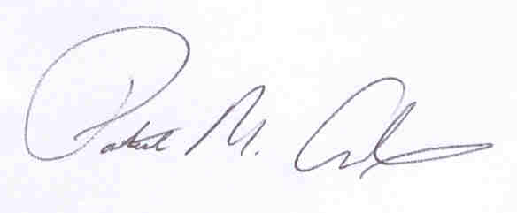
Patrick M. Adams
Secretary, Joint Committee

